Guy’s and St Thomas NHS Foundation Trust – Oracle Cloud Integration

EXT039-VBS
AR Self Service Invoice Process

Revision: 1

Table of Contents
1 Overview 4
1.1 Scope 4
1.2 Assumptions 4
2 Business Requirements 4
2.1 Business Needs 4
2.2 Detailed Business Requirements 5
2.2.1. Summary Screen 5
2.2.2. Self Service Invoicing 6
2.2.3. Customers 8
2.2.4. Approvals 9
2.2.5. Interfaces 10
2.2.6. Alerts 10
2.3 Major Features 10
2.3.1. User Access 11
2.3.2. Self Service Invoicing – Summary Page 11
2.3.11.1. Notification Description 17
2.3.11.2. Notification Details 17
2.4 Definitions 18
3 Functional Design 19
3.1 Assumptions 19
3.2 Data Flow 19
3.3 Pre Requisite Configuration 19
3.4 Mappings, Lookups & Other business considerations 21
4 User Procedures 22
5 Error Handling 24
6 Unit Test Scenarios 25
7 Appendix 1: Current EBS Overview 26
8 Appendix 2: Current EBS MD050s 26
9 Appendix 3: Income and Income Request Form (Current EBS) 27
10 Appendix 4: Income and Income Request Notification (Current EBS) 30
Open and Closed Items 31

Revision History
Revision Comments | Revised By | Revision Date | Version
Initial Draft | Mick Sagoo | 16/10/20 | 0.1
Updates made after initial Integration Workshop | Mick Sagoo | 23/10/20 | 0.2

Reviewers
Reviewer Name | Title / Role | Date
David Twerdochlib | GSTT Client Systems Manager
Lynne McAlister | GSTT Finance Programme Manager
Richard Houlbrook | GSTT Senior ITC Manager
Kam Ng | GSTT ITC Manager
Aleksandra Wojciechowska | GSTT ITC Systems Manager

Overview

Scope

This document will include:-
- Details of the business requirements
- The solution design of the interface to meet these business requirements to include:-
  - Major features of the design
  - Details of the data file format and its mapping into Oracle Cloud ERP
  - Application configuration required to support the interface
  - User procedures
  - Error Handling procedures
  - Unit Test scenarios
- Any other business considerations and supporting information

Assumptions

Business Requirements

Business Needs

This customisation is intended to provide a distributed facility to submit Income Requests. This is a facility that is not offered by the current native Oracle ERP Cloud Receivables Applications. This would incorporate departmental and Income Department approval prior to interfacing into Oracle ERP Cloud.

There is an existing customisation in place in GSTT’s current Oracle EBS environment, and this is currently largely fit for purpose for the required needs of the business. As the current user base is familiar with this process, it is required that a similar solution is implemented to work with Oracle ERP Cloud Applications going forward.

Detailed Business Requirements

Summary Screen

For reference, below is the current Summary Screen in Oracle EBS:-

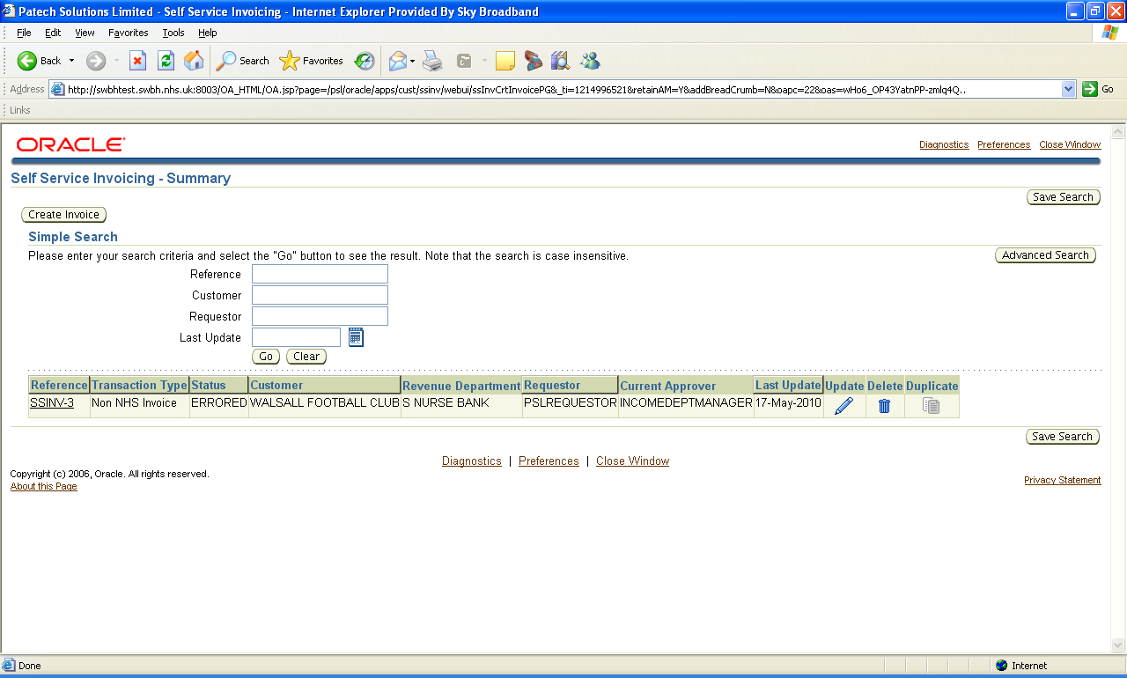

The solution is required to have the following functionality around a Summary Screen:

- The initial screen will have several functions
  - Ability to process to the Create Invoice Screens
  - Show history of Transactions with following fields
    - Reference
    - Transaction Type
    - Status
    - Customer
    - Revenue Department
    - Requestor
    - Current Approver
    - Last Update Date

  - Simple search facility to search previously raised invoices by requestor based on:
    - Reference
    - Customer
    - Requestor
    - Last Update Date

  - Ability to Update transactions which are in a status of ENTERED, REJECTED or ERRORED
  - Facility to Duplicate transactions which are in status of COMPLETE
  - Facility to Delete transactions which are not in status of SUBMITTED or COMPLETE

Self Service Invoicing

For reference, below is the current ‘Self Service Invoicing – Invoice Header’ screen in Oracle EBS:-

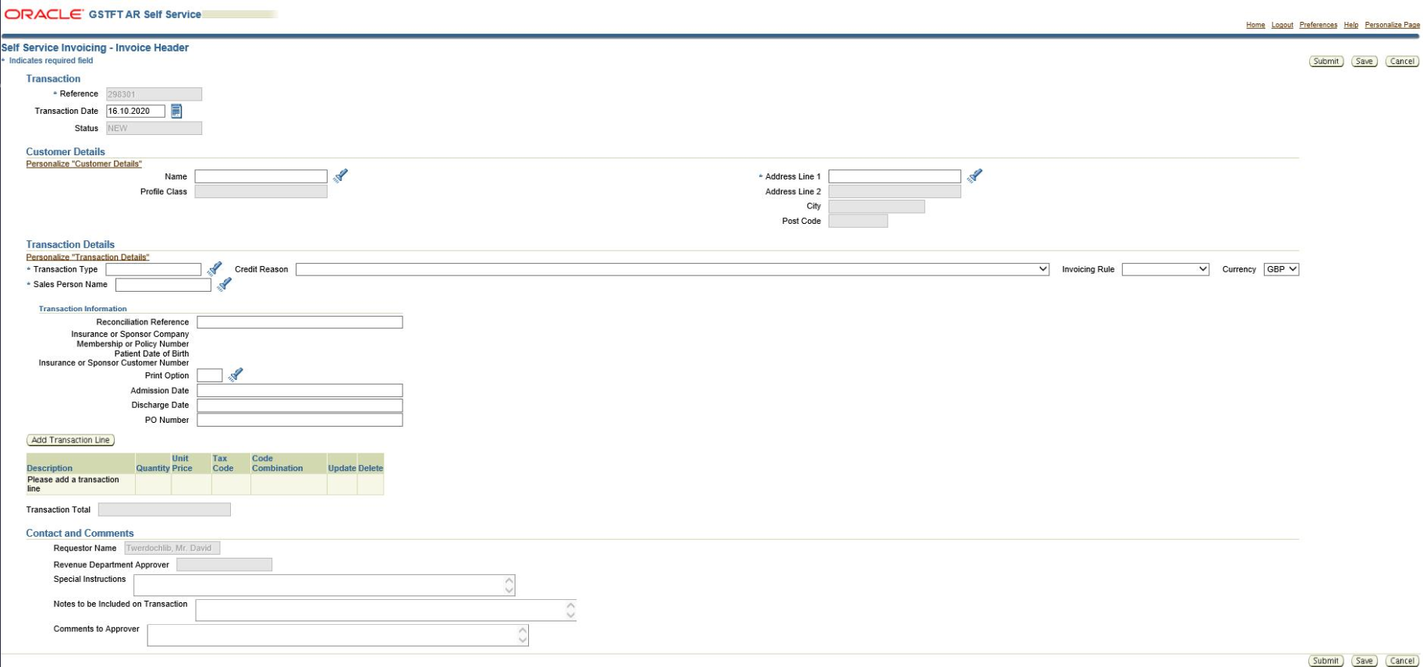

For reference, below is the current ‘Self Service Invoicing – Invoice Line’ screen in Oracle EBS:-

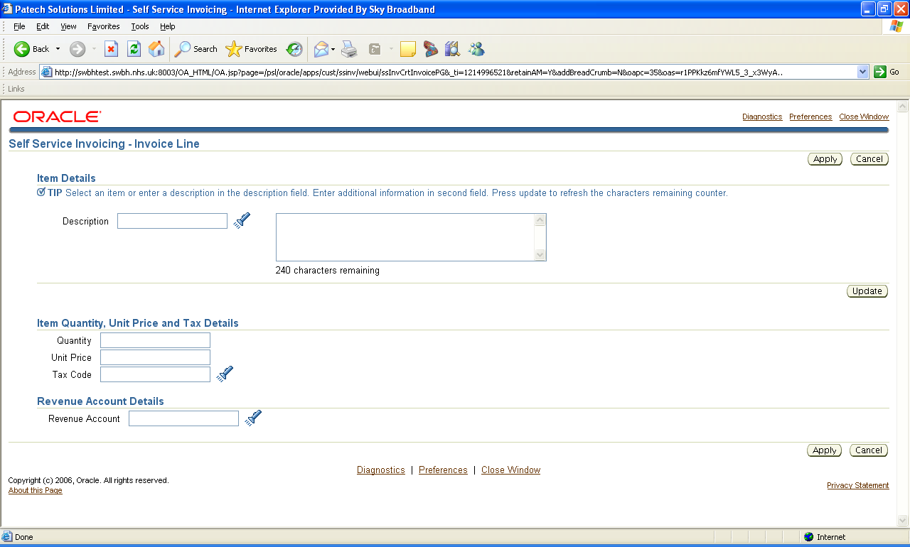

The solution is required to have the following functionality around Self Service Invoicing

- The ability to raise requests for Invoices and Credit Notes

- Entry of Transaction Type to allow requests for Invoices. The list of values available in this field is limited (by DFF on the Transaction Type) to types deemed applicable to Self Service Invoicing.

- Entry of a Description of the goods / services being provided. As with the standard field in the Oracle Transactions form, this field will either allow:
- The selection of predefined text, based on a list of values, validated against ‘Memo Lines’ held in the Oracle system OR
- The entry of a Free-text description, where no Memo Line exists in the list of values above.
Memo line defaulting needs to be discussed and feasibility check needs to be done, but we can have it as a free text field
- Entry of a Quantity, Price, Tax Code and Revenue Code for each of the Goods / Services being provided.

Note that if a ‘Memo Line’ has been selected in the Description field then the associated line values will be defaulted, where available, from the Memo Line details (per standard Oracle functionality).

- Entry of multiple Invoice Lines per Invoice being processed within the same revenue Cost Centre.
Does this mean that lines need to be validated before save to verify if all of them have same cost center or not? This needs to be discussed further

- Entry of a Requestor for this invoice, as it may not be the user who has signed on and is processing this invoice.
We need to have requestor as a mandatory field and that will drive the approvals.
Note that this value will default to the Employee name of the user logged on to the system, but may be changed based on an allowable list of values, validated against employees held in the Oracle system.
How to identify the requestors in ERP that needs to be synced to requestor’s lov in VBCS?
- Entry of additional Comments for this transaction. These comments may allow the user to convey additional details to the Department Manager in order to make an ‘approval’ decision. These comments are transferred to the Comments field on the AR Invoice in the application

- Entry of a Revenue Department for the invoice based on a list of values, validated against active Revenue ‘Locations’ held in the Oracle system. A location will be identified as a ‘Revenue’ location by use of a Descriptive Flexfield on the Locations form. This will ensure that the user is limited to a specific list of locations.

As per our discussion, requestor will have approver stored in DFF but above and below paras are talking about logic to derive the approver. We need to discuss this

The ‘Department’ will allow the system to identify the Site, Division and Cost Centre segments of the Revenue account as these values are currently held against each Department through a Descriptive Flexfield (DFF) on the Locations form in Oracle ERP Cloud.

Note – the Revenue Department should default from the ‘Location’ field on the Employee form. The employee is identified from the User signing on to the system. The user will have the ability to update this default value.

- Entry of Special Instructions for the invoice based on a list of values held in the Oracle system. The solution uses this field to hold internal contact information which is subsequently available for printing on the Sales Invoice.

Again this needs to be discussed

Customers – This section itself is not discussed. All we discussed is to sync customers from ERP Cloud so that requestor can pick him up from drop down. Do we need these additional screens to create customer and address in VBCS? This changes the entire scope and lot of points will come into picture.

For reference, below is the current ‘Customer Creation’ page in Oracle EBS:-

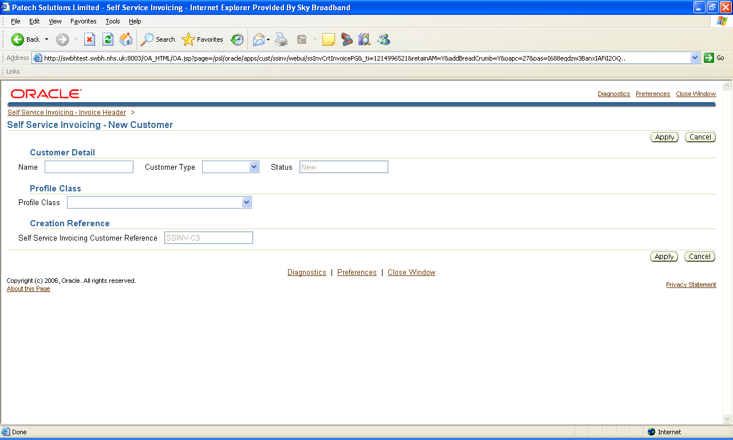

For reference, below is the current ‘Customer Address Creation’ page in Oracle EBS:-

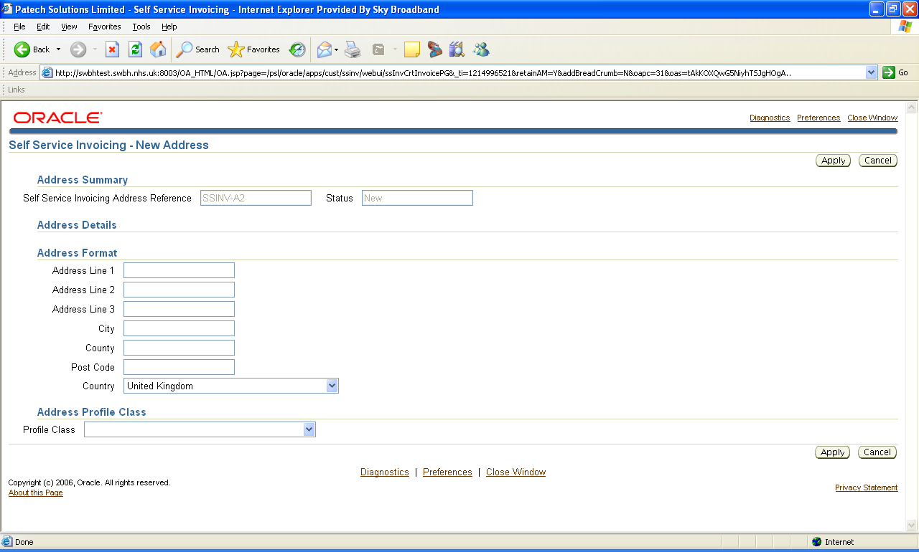

The solution should deliver the following functionality around customers:

- The ability to select a customer from a list of values, validated against ‘active’ customers held in the Oracle system.

- If a customer does not already exist, the ability to enter a new customer name.

- The ability to select a customer address from a list of values, validated against ‘active’ addresses held in Oracle ERP Coud. Note that only active addresses for the Customer previously selected should be available to the user.

- If a customer address does not already exist, the ability to enter a new address.

- The ability to select or enter a new contact name against the customer.

Approvals

For reference, below is the current Invoice Request Approval Notification in Oracle EBS:-

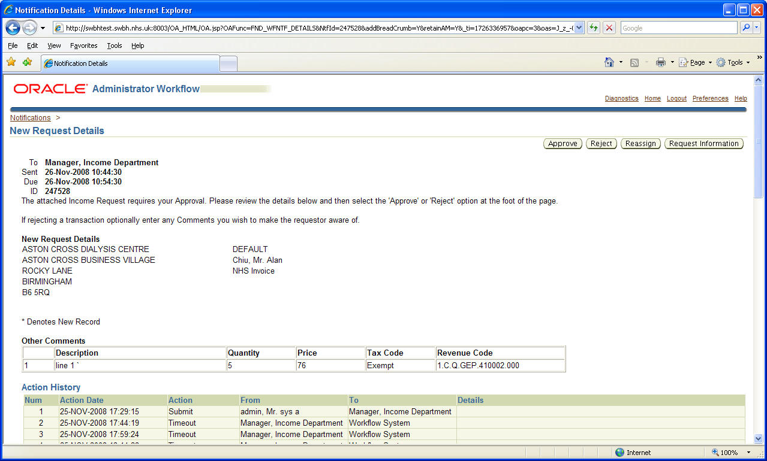

The solution should deliver the following functionality around approvals:

- The ability to submit an invoice to a Department Manager for approval. The submission is in the form of a notification / e-mail, with the full invoice details being displayed to the Department Manager in order for them to make an approval decision.

- The ability for a Departmental Manager to Approve or Reject an Invoice Request from either a Notification or Email. Where applicable, the Manager will have the ability to attach comments to a Rejected Notification in order to notify the user of any reasons why the transaction has been rejected.

- The ability to inform a User, via a Notification or Email, of an Invoice Request having been Approved or Rejected, with Manager comments where applicable, triggered by the action by the Manager.

- The ability to send reminders to Departmental Managers where the original notification has not been actioned on within a certain time period.

- The ability to escalate an approval request to the Income Department where a Departmental Manager has not actioned an approval request after a specified number of reminders.

- The ability to trigger an ‘Approval’ notification to the Income Department upon approval of an Income Request by the Departmental Manager.

Interfaces

The solution should deliver the following functionality around interfaces:

- Creation of new Customers where the User has selected the ‘New Customer’ flag on an Approved income request form.

- Creation of new customer addresses where the User has selected the ‘New Address’ flag on an Approved income request form.

- Creation of new invoices based on Income Requests approved by the Department Manager.
We discussed only point#3. Can you clarify if only point#3 is in scope?

Alerts

The solution should deliver the following functionality around alerts:

- An alert must be sent to the Income Department to identify any New Customers created through the use of the income request form.

Is this in scope?

Major Features

User Access

Oracle Identity Cloud Services (IDCS) will be used to manage the users and groups that need to access this Invoice Request functionality. The core user groups will be maintained separately to the main Oracle Cloud ERP Applications users.

The user groups will be as follows:-
‘Requestors’
‘Approvers’
‘Finance Final Approvers’ for the Income Systems Team (tbc)

The same users can be in multiple user groups.

I will not get into this as it was mentioned that admin team will take care of user creation and other related activities.

Self Service Invoicing – Summary Page

As per the current solution, the first page opened will be the ‘Self Service Invoicing – Summary Page’.

This will allow for the features as described in the Detailed Business Requirements of this document.

Additionally, it will allow for searching based on multiple criterion (to narrow down results) - tbc

    - Validation when opening the Invoice Header Page

There will be the following validations put n place when opening the Invoice Header page:-
  - Whether the approver of the Request is valid
  - Which organisation the Invoice Request is being raised for. Only information related to that organisation will be displayed in the form.

I believe org refers to BU in Cloud. This needs a detailed discussion

    - Self Service Invoicing – Invoice Header Page

The Self Service Invoicing – Invoice Header Page will allow for the features as described in the in the Detailed Business Requirements of this document.

Comments related to the key fields on this page are noted below:-

Section | Field Name | Data Source | Display Element Type | Comments
Transaction
 | Reference | OIC | System generated reference number | Note: This Reference Number is important as backing documents reference this.
 |  | OIC | Updatable date field | This should not be back-dateable
  Transaction Date
 | Status | OIC | Not Editable | Reflects the status of the transaction
Customer Details
 | Name | ERP Cloud | Lov Based | Synced every 12hr  On Demand
 | Address fields | ERP Cloud | Lov Based | Synced every 12hr  On Demand
 | Profile Class | ERP Cloud | Not Editable | Synced every 12hr  On Demand
Transaction Details
 | Transaction Type | ERP Cloud | Lov Based | Synced overnight
 | Sales Person Name | ERP Cloud | Lov Based | Synced every 12hr  On Demand
 | Credit Reason | ERP Cloud | Lov Based | Synced overnight
 | Invoicing Rule | ERP Cloud | Lov Based | Synced overnight
 | Currency | ERP Cloud | Lov Based | Synced overnight
Transaction Information
 | Reconciliation Reference |  | Text Field | Multiple uses including to capture Payroll Number, Overseas Visitors and Catering.
 | Insurance or Sponsor Company |  |  | Defaulted from Customer Information
 | Membership or Policy Number |  |  | Defaulted from Customer Information
 | Patient Date of Birth |  |  | Defaulted from Customer Information
 | Insurance or Sponsor Custom Number |  |  | Defaulted from Customer Information  Will this info be available in ERP Customer Master? We need to discuss the impact on this from data sync perspective and ability to create new customers from VBCS
 | Print Option | ERP Cloud | Lov Based | Synced overnight
 | Admission Date |  | Text Field
 | Discharge Date |  | Text Field
 | PO Number |  | Text Field
 | Other Recharge Reason
Contact and Comments
 | Requestor Name |  | From user Record
 | Revenue Department Approver |  | ERP Cloud | Employee DFF
 | Special Instructions
 | Notes to be included on Transaction
 | Comments to Approver

- Transaction Date field - should not be back-dateable
- Profile Class field - will default from the Profile Class held against the Customer Header record
- Credit Reason field – The user will only be prompted to enter a Credit Reason is the Transaction Type is a Credit transaction type – tbc
- Invoicing Rule field – only the option to raise requests with the ‘Invoice in Advance’ Invoicing Rule will be available – tbc
- Transaction Information Area – the information diaplayed in the ‘Transaction Information’ area of the page will be determined by the Transaction Type that is chosen
- Purchase Order Number – If the PO Number field is not populated the user will be prompted with a message before submitting the request. The message will ask if the user is sure that they want to submit the invoice request with no Purchase Order number populated.

- Option for creating ‘Incomplete’ Invoices
An option to create the resultant transactions in Oracle ERP Cloud Receivables Applications as ‘Incomplete’ will be made available. This will only be available and visible to the final approvers (ie. Income Systems Team) when they are in a position to provide final approval to create the Invoice/Credit Note. This is not part of the existing solution, but will be developed as part of the new solution going forward. Note, that the default option will be to create the Invoice Request as ‘Complete’, but this part of the solution will provide an option (should it be required) to create the Invoices as ‘Incomplete’.

    - Self Service Invoicing – Invoice Line Page

The Self Service Invoicing – Invoice Line Page will allow for the features as described in the in the Detailed Business Requirements of this document.

Comments related to the key fields on this page are noted below:-

Section | Field Name | Data Source | Display Element Type | Comments
Item Details
 | Description | ERP Cloud | Memo Line Item Name  Memo Line Item Description  Income Code  LOV, but can be overwritten | Lov as well as updatable field  Synced every 12hr  On Demand  Not sure of Lov+Updatable is possible, if not we can ask users to either memo line or add description in additional description field
 | Additional Description |  | Text Field
Item Quantity, Unit Price and Tax Details
 | Quantity |  |  | Default Value 1
 | Unit Price
 | Tax Code |  |  | Updateable
Revenue Account Details
 | Segment 1:  Organization | ERP Cloud |  | Synced Overnight  On Demand
 | Segment 2:  Cost Centre |  |  | Synced Overnight  On Demand
 | Segment3:  Subjective |  |  | Synced Overnight  On Demand
 | Segment4:  WGA |  |  | Synced Overnight  On Demand
 | Segment5:  Intercompany |  |  | Synced Overnight  On Demand
 | Segment6:  Analysis |  |  | Synced Overnight  On Demand
 | Segment7:  Spare1 |  |  | Synced Overnight  On Demand
 | Segment8:  Spare2 |  |  | Synced Overnight  On Demand
Transaction Line Information Details
 | Line Reconciliation Reference |  | Text Field

- Description field – the Memo Line will not be updateable as it is in the current set up

All points mentioned below needs to be discussed.

- Revenue Account details
  - These should reflect the new Chart of Accounts structure
  - All segment values should default based on the AutoAccounting Rules (including Salesperson and Memo Lines chosen)
  - The ‘Analysis’ & ‘Spare’ segments will be the only segments which are updateable by users. All other segments will be non-updatable

- When applying changes to the page, validation to ensure there are no ‘$’ characters in the Memo Line description will be undertaken.

- Control characters in the Description field currently are not recognized and therefore only the first line ultimately gets printed out on the final invoice. It will be ensured that control characters do not cause the same issue in the solution going forward

- Split Coding:
The current solution does not allow for split coding (multiple distribution lines for an invoice line), but the solution going forward will provide this ability. There are instances, for example with Overseas Income, where income needs to be split across Cost Centres.

- In addition to the validation that is existent in the current solution (for invalid Account Code Combination), the solution in ERP Cloud will have extra validation for the scenario where a Cost Centre is set to be non-Postable (even if it is active).

    - Approval Hierarchy

There will a Descriptive Flexfield (DFF) held against the Employee to capture the ‘AR Self-Service Approver’. This will be used to build the Approval hierarchy of the invoice request.

Logic will be built to validate that a valid Department Approver exists for the request being created. This will be done at the start of the invoice request process (when opening the invoice request page)

    - Approval process

The Income Systems Team provide the final approval to invoice requests before they are submitted to be interfaced into the Oracle ERP Cloud Receivables Applications.

Standard Invoice Request Approval:

Step 1 – Invoice Request is entered by requestor and sent for approval to the Requestor’s Manager

Step 2 – Requestor’s Manager approves the Invoice Request

Step 3 – The Income Systems Team (for both GSTT and ETL organisations) pick up the Invoice Request and conduct checks, including GL coding and VAT coding

Step 4 – Assuming all the details are correct the Income Systems Team provide ‘final approval’ to create the Invoice Request as an Invoice
Invoice will be marked as Rejected if there is problem with either GL/VAT and requestor to raise a new Invoice request again. Is this correct understanding?

Credit Note Approval:

Credit Notes will require extra approval (compared to standard Invoice requests).

Step 1 – Credit Note Request is entered by requestor and sent for approval to the Requestor’s Manager

Step 2 – Requestor’s Manager approves the Credit Note Request

Step 3 – The Income Systems Team (for both GSTT and ETL organisations) pick up the Credit Note Request and conduct basic checks, including GL coding and VAT coding

Step 4 – Assuming all the details are correct the Income Systems Team forward / re-assign the Credit Note Request for approval (as required by the Trust’s policy) to either the Chief Accountant, Senior ITC Manager or ITC Manager.

Step 5 – The Chief Accountant, Senior ITC Manager or ITC Manager approve the Credit Note Request

Step 6 – The Credit Note Request then comes back to the Income Systems Team to conduct further checks.

If all details are correct, and the Credit Note is less than £100k in value, then the Income Systems Team provide ‘final approval’ to create the Credit Note Request as a Credit Note.

If the Credit Note is £100k or more in value then approval is sought (currently off-line) from the Finance Director. On receiving the Finance Director’s approval and assuming all Credit Note details are correct, the Income Systems Team provide ‘final approval’ to create the Credit Note Request as a Credit Note.

Complex Additional Logic highlighted above needs to be plugged into PCS process which was not discussed in earlier call.

The solution going forward will be able to accommodate the above approval process to allow for the necessary financial control and adherence to policy.

    - Self Service Invoicing – New Customer Page

The Self Service Invoicing – New Customer Page will allow for the features as described in the in the Detailed Business Requirements of this document.

    - Self Service Invoicing – New Customer Address Page

The Self Service Invoicing – New Customer Address Page will allow for the features as described in the in the Detailed Business Requirements of this document.

    - Notification – Income and Customer Request Approval
Approval process required for customer is not outlined below

      - Notification Description

The notification should be sent

a) on the selection of the Submit Invoice button in the Income and Customer Request form above. It will be routed to the Departmental Manager by selecting the employee held in the ‘Supervisor’ field in Oracle of the User who has submitted the request.
b) on the selection of the Approve button by the Departmental Manager in this same notification. It will be routed to the Income Manager as held in the new profile option.

This notification allows the Departmental Manager and the Income Manager, in turn, to review the Customer and Invoice requests and action this request by either Approving or Rejecting. If Rejected by either party, the Departmental Manager/Income Manager should be able to add Rejection Comments prior to rejecting the requirement.

      - New Request Details Zone

This zone will show specific details of the Invoice request, showing sufficient information for the Departmental Manager to make an informed decision as to whether the transaction should be Approved or Rejected.

This zone will allow the Departmental Manager to select an Approve or a Reject button. If the ‘Reject’ option is to be selected then the user may also enter a Reject Reason in the available Free text box.

      - Timeout

The timeout for applications will be on a ‘3+3+3’ basis between the Requestor and the Approver, and also another ‘3+3+3’ between the Approver and the IDSM team.

‘3+3+3’ means the first Approval Notification will be sent, then:-
  - If no response, a second Reminder Approval Notificaiton will be sent after 3 Days
  - If no response is received to the second Approval notification, a third Approval notification will be sent after 3 days
  - If no response is received to the third Approval notification, the notification will time out and the the notification will automatically result in a Rejection.

      - Notification Details

In its simplest form following Approval and successful Interface to core AR, the notification should detail the following:

Creation of Income Request Reference - XXXXXX
The following invoice has been approved and created

Request Number XXXXXXXX
Customer XXXXXXXXX

No further Action is necessary

In its simplest form following Approval and unsuccessful Interface to core AR, the notification should detail the following:

Errors have occurred processing invoice reference XXXXXX
The following errors were encountered:
XXXXXXXXX

Please correct and either retry or cancel

    - Notification – Rejection Response

Notification Description

This notification allows the original requestor of a transaction to be informed of a rejection of a request. It should be activated on select of the Reject button in the Income and Customer Request notification. It should be sent to the User who sent the request to the Department Manager.

Notification Details

In its simplest form, the notification should detail the following:

Rejection of Income Request
XXXXXXXXXXX has rejected your request

Request Number XXXXXXXX
Customer XXXXXXXXX
Reason: XXXXXXXXXXXXXXXXXXXXXXXXXXXXXXXXXXXXXXXX

Please cancel or adjust and resubmit this request as necessary.

Should a rejected request be allowed for resubmission?

    - Notification Landing Page

When approvers are logging into the Notification Landing page to review all of their open approval notifications, there will also be a field showing the ‘Total Number of Notifications in the List’ displayed . This will allow approvers to see how many invoice requests to action and will be useful as some approvers have a high volume of requests to action at the same time.

As mentioned in the call, Once approver logs into OIC PCS, they will be able to see all the approval notifications pending in their queue as out of the box functionality

    - Customer Interface

This interface should be activated on selection of the Approve button in the Income and Customer Request notification, when the ‘New Customer’ or ‘New Address’ option has been selected.

This needs to be discussed

    - Invoice Interface

This interface should be activated on selection of the Approve button in the Income and Customer Request notification.

Should the interface fail for any reason an FYI notification is sent to the Income Department Manager advising of the Issue.

What should happen next in above scenario?

On successful interface to Core AR an FYI notification is sent to the Requestor and the Income Department Manager.

    - Identifying approvers in the Income Systems Team

There will be a DFF against the HCM Employee Record in Oracle Cloud Applications to identify those Employees who are members of the Income Systems Team (currently GSTTIDM and ETLIDM users).

This DFF will be used by the solution to identify the individual Employee that has finally approved a given Invoice Request. This will allow for more effective management of the Income Systems team work queue and also provide better audibility than is currently the case.

This needs to be discussed

    - Other Features

Copying Invoice Requests:

The solution will provide the ability to copy existing Invoice Requests. Only Invoice Requests which are completed and were created by the same Requestor will be available for copying.

When copied, then the Edit page will be available with all details to be updateable. The Approver Name and Transaction Date fields will be blanked out in the copied Invoice Request.

Deleting Invoice Requests:

The solution will provide for the ability to delete Invoice Requests. Only Invoice Requests that have not been submitted will be available to the Requestor to delete.

Definitions

FBDI = File-Based Data Import

OIC = Oracle Integration Cloud

ESS = Enterprise Scheduling Services

GSST = Guys’ and St Thomas’ NHS Foundation Trust

Functional Design

Assumptions

The following are key assumptions made about the development of the interfaces:

- All transactions loaded via the interface are considered as complete, accurate and pre-approved by the department.
- No need for supporting documentation to be submitted when income is interfaced (i.e. supporting data and transmission of invoices is to be handled by the income generating department).
- Invoices may be processed in any enabled currency; usually GBP, USD or EUR.
- Currency Transactions will not use future dates as if Rates are not defined this will cause the interface to error.
- Currency Rates will be maintained by GSTT in Core Applications for all ‘active’currencies for all ‘current’ AR and GL Periods.

Data Flow

Not Applicable

Pre Requisite Configuration

This section details the additional configuration required by GSTT in order to start using the customized process detailed above. Certain elements are already configured in the existing production system and require no additional set-up; they are included for completeness only.

Invoice Source
GSTT currently has a Source in place for all manual Transactions.
This source is required to be used for the Self Service Invoice Transactions

Name All Transactions
Type Manual
Description All Receivables Transactions under 1 Sequence
Active Checked
Effective Dates 01.01.1970
Auto Batch Numbering Checked
Auto Transaction Numbering Checked
Copy Doc Number to Transaction Checked

Any additional details will be completed by the Technical team if required.

Transaction Types
GSTT currently uses multiple Transaction Types for Invoices and multiple Transaction Types for Credit Notes. It was not deemed necessary to create any additional Transaction Types at this point in time. If GSTT determines that additional Transaction Types are required they may set these up in the future but this will have no effect on the functionality of this development.
Transaction Types will hold a DFF which identifies if the Transaction Type is available to select in the Self Service system.

Memo Lines
The Trust currently uses System Items but are in the process of switching to the sole use of Memo Lines. If any new Memo Lines are required GSTT will set these up and ensure that they have valid revenue (income) accounts assigned.

AutoAccounting
AutoAccountingRules for Revenue and Receivables will need to be set up as per agreed business requirements.

Employees
Each of the Requestors and Department Managers must be created as employees as part of this customisation (note that some users may already be defined within Oracle ERP Cloud as they currently have access to the finance system).
Employees must be created with the following details for use in Self Service.

Users
Each of the Requestors and Department Managers must be created as Users within User Groups within Oracle Identity Cloud Services

Mappings, Lookups & Other business considerations

Layout Description
Data Element Name | Column | Field Length | Mandatory Field | Comments

User Procedures

Income Requestor

The following are the main User procedures

Search for Existing Request / Invoice

      - Enter the required search parameters to limit transactions to be returned
      - Select the Go button to run specific query.

Enter New Request

            - Select the Create Invoice button to start processing a new invoice request.
            - Search for an existing Customer using the list of values option.
            - When an existing Customer has been selected the Address will default to the Primary Bill-To address for that customer. The user may update this address to any other active Bill-To address that exists for this customer.
            - Select a Transaction Type from the allowable list of values, to determine the type of transaction being processed.
            - Enter the Sales Person details from an allowable list of values. Note that this value will determine Cost Centre that the Revenue will be posted to in the General Ledger.
            - Where applicable, enter a value in the Special Instructions field. This will be free text and holds the related Invoice number on Credit Note Requests.
            - Enter the relevant DFF data for the Invoice Request which will be based upon the Transaction Type used. Some DFF data will be from an allowable list of values and others will be free text.
            - Where applicable, enter the Accounting Rule and Invoicing Rule information.
            - Where applicable, update the Currency from the default of GBP.
            - Select the Add Invoice Line button to enter line details.
            - Select the goods or service being provided in the Description field, from the valid list of Memo Line values.
            - Enter the Quantity figure of goods or services being provided. This will be a positive value.
            - If the goods or services were selected from a list of values then the Price should have been automatically populated. If this is not the case then enter this value. This will be a positive value if the item is an Invoice Line and a negative value if the item is a Credit Line. Note that this should be the price NET of any tax. The total value of the invoice line will be calculated as follows:

(Quantity * Price) + VAT

Where VAT is calculated from the Quantity, Price and VAT code.

            - The Tax Code will have been automatically populated using a hierarchy of values based on Customer Address, Memo Line, Revenue Account or System Options.
            - If the goods or services were selected from a list of values then the Income Account should have been automatically populated.
            - If an Accounting Rule and an Invoicing Rule have been entered on the Header screen then a Rule – Duration and a Rule – First Date will be required depending on the values entered at the header level. If the Accounting Rule and an Invoicing Rule were not populated at Header then they will not be available to update. If the Header screen is amended after completion of the Invoice Line zone ‘Page’ validation will require these fields to be populated prior to submission.
            - Select Apply to commit this invoice line.
            - Repeat from Add Invoice Line steps for each line to be included on the invoice.
            - The Requestor will have been defaulted based on the User details. If this value is incorrect (e.g. the invoice is being raised on behalf of another requestor), then change this field using the list of allowable values.
            - Enter any additional Comments relating to this invoice that may be useful to either the Department Manager approving this document or the Income Team who will ultimately finalise the document for submission to the customer.
            - Once all details have been entered, select either:
              - Submit Invoice button to send income request to Department Manager for approval.
              - Save button to save the transaction for submission at a later date.

Department Manager

The Department Manager will receive a Notification / Email requesting approval for any Income Requests where they have been identified as the ‘Supervisor’ of the Requestor.

The following are the main User procedures:-

- Review all details of the income request. The approver should not be able to update any details. They should have the option to approve or reject as required.
- If the details are correct and acceptable, select the Approve button.
- If the details are not correct then enter comments in the Reject Reason box and then select the Reject button.
- Both options 2 & 3 above will result in a notification / email being sent to the requestor stating whether the request has been approved or rejected and the reason for the rejection, if entered.
- Approval of the request will result in an additional approval request being sent to the Income Team as they have the final say as to whether the invoice details are created in core Receivables.

Income Department

The Income Department will receive a Notification / Email requesting approval for any Income Requests.

- Review all details of the income request and amend as necessary.They should have the option to approve or reject as required.
- If the details are correct and acceptable, select the Approve button.
- If the details are not correct then enter comments in the Reject Reason box and then select the Reject button.
- Both options 2 & 3 above will result in a notification / email being sent to the requestor stating whether the request has been finally approved or rejected and the reason for the rejection, if entered.
- Approval of the request will result in details being passed to Oracle ERP Cloud nReceivables for creation of invoices.

Error Handling

To be completed

Unit Test Scenarios

The following table lists the Test Cases that should be considered by this Functional Design:

Test Ref | Unit Test Case | Expected Results
 | Transaction Types limited to those flagged as available | Only those Transaction Types with the Self Service DFF flagged as ‘Yes’ will be available for use in Invoicing.
 | Entered Transactions but not Submitted can be Cancelled. | Transactions should remain on Summary Screen with a status of CANCELLED and not be available for update
 | Enter Transaction and submit | Transaction will be available to Approve in the relevant Supervisors notifications
 | As Supervisor Approve Invoice Request | Transaction will be available to Approve in the Income Department notifications
No REST API available to validate the combination. Only SOAP service available. Long alternate approach will be required to achieve this | Enter a transaction with a violation to Cross Validation Rules in the Accounting Lines | Warning message should be seen and Invoice Request cannot be submitted
Need to discuss this | Enter a Credit Note and reference the related Invoice in the Special Instructions field. Submit through to final Approval. | In core Receivables the related Invoice number should be specified in the Special Instructions field of the Credit Note.

Note: Detailed Test Scenario will be built during the test loading / actual testing process.

Appendix 1: Current EBS Overview

This is the current Oracle EBS solution overview as captured in the ‘GSTT Advisory Services Integration Strategy Advisory Document’ in the Advisory stage of the project.

AR Self service:
AR Self service screens are implemented to created sales invoices and credit notes. Using this process, users can do below activities:
Create Invoice
Search for Invoice Details
Update invoices, not approved.
Copy invoices from completed invoices.
Delete invoices that are rejected
Interface Invoice into AR after approval
Approval flow is used to approve the invoices created using AR self service screens and after approval, the invoices are created into Oracle AR. Around 350 Users have access to AR self service screens today.
GSTT needs AR self service screens to be implemented outside the ERP cloud application. Approval workflow is same as employee to GL. The response times are 3+3+3 between the requester and the approver and a further 3+3+3 between the approver and ITC Income & Systems team who receive the approved transaction and approve or reject or ask for more information before the transaction is created in Oracle. so this is a twostep process.. Then the flow times out. If there are any DFFs at the customer set up level, these may be downloaded automatically in to the request as it is being created by the requester. The requester may also add additional information to the request in AR Self Service.. Once approvers receives notification, ITC login back into AR self service screens to review and approve/reject/request extra information on the invoice.
Once the interface created AR Invoice, the invoice number is maintained back in the AR self service invoices. There are alerts in the system to notify about bad data in the invoice information.
GSTT required AR self service screens fetch customer , salesperson, memo line data, DFFs where relevant and approver details from core Oracle.

Appendix 2: Current EBS MD050s



Appendix 3: Income and Income Request Form (Current EBS)

The following is a summary of how the self service invoicing solution looks – note this shows the Patech Standard Template forms and not GSTT specific ones:

Summary Page

Invoice Update/Create Page

Customer Creation Page

Address Creation Page

Invoice Line Update/Create Page

Appendix 4: Income and Income Request Notification (Current EBS)

The following is an example of the notification:

Open and Closed Items

Item ID | Status (Open / Closed) | Item Requiring Action or Resolution | Responsibility | Target Completion Date | Resolution | Closed  Date
EXT039_001 | Open | Distinct list of Credit Reasons required. Existing values to be looked at and cleansed | GSTT | 13/11/20
EXT039_002 | Open | Change to current design requested – to only prompt for Credit Reason if Transaction Type is a Credit Transaction Type. V1 to look into. | Version1 (Technical Team) | 13/11/20
EXT039_003 | Open | GSTT cannot currently raise request with ‘Invoice in Advance’ Invoice Rule because EBS R12 Interface table cannot accept it. GSTT only require ‘Invoice in Advance’ option. PK to look into whether ‘Invoice in Advance’ option can be used in Oracle ERP Cloud. | Version1 (Technical Team) | 13/11/20
EXT039_004 | Open | Change to current design requested Can Memo Line Description field be restricted so that it cannot be overwritten. V1 team to look into. | Version1 (Technical Team) | 13/11/20
EXT039_005 | Open | Change to current design requested – Revenue Account details should all default based on Salesperson and Memo Lines chosen , and not to be updateable (business rules) le by users. V1 team to look into. | Version1 (Technical Team) | 13/11/20
EXT039_006 | Open | Revenue Account details to be updated to reflect new Chart of Accounts structure | Version1 (Technical Team) | 13/11/20
EXT039_007 | Open | In new design, the ‘Analysis’ and ‘Spare’ segments in the Chart of Accounts for the Revenue Account string should be updateable | Version1 (Technical Team) | 13/11/20
EXT039_008 | Open | Solution options of how the Organisation that the Invoice Request relates to needs to be put together and presented to GSTT | Version1 (Technical Team) | 13/11/20
EXT039_009 | Open | Ensure that control characters do not interfere with the Invoice Print when fields (eg. Description) are imported into Oracle ERP Cloud. This is a current issue which needs resolving. | Version1 (Technical Team) | 13/11/20
EXT039_010 | Open | Solution for how the hierarchy is to be built for the approval needs to be presented to GSTT. Current proposal is to hold a DFF for ‘AR Self-Service Approver’ against the HCM Employee Record in Oracle ERP Cloud. | Version1 (Technical Team) | 13/11/20
EXT039_011 | Open | Change to current design requested – Build in logic to validate a valid Department Approver up front to prevent invalid request being submitted with invalid approver | Version1 (Technical Team) | 13/11/20
EXT039_012 | Open | New requirement – to be able to split Invoice Request lines across multiple distributions (particularly Cost Centre). Version1 to look at solution options. | Version1 (Technical Team) | 13/11/20
EXT039_013 | Open | Error message that is required to be displayed for the validation error for Cost Centres that are not postable to be provided. | GSTT | 13/11/20
EXT039_014 | Open | Can attachments be put o the AR Self-Service form and for this to be imported into the application. Version1 to look into options and present back | Version1 (Technical Team) | 13/11/20
EXT039_015 | Open | Options for selecting the organisation that the Invoice Request relates to, and for only that information to be displayed in the Invoice Request forms. Feasibility and options to be looked at and presented back | Version1 (Technical Team) | 13/11/20
EXT039_016 | Open | New Requirement - PO Number message to be incorporated to remind user that PO Number is blank before submitting. V1 team to incorporate into solution | Version1 (Technical Team) | 13/11/20
EXT039_017 | Open | New requirement – Credit Note approval process to be built into solution | Version1 (Technical Team) | 13/11/20
EXT039_018 | Open | New requirement – Only final approvers of Income Request form to be able to have an option to raise an invoice as ‘Incomplete’ | Version1 (Technical Team) | 13/11/20
EXT039_019 | Open | New requirement – Options around the use of multiple criteria and dependent crietria on the Search page to be looked at and presented back | Version1 (Technical Team) | 13/11/20
EXT039_020 | Open | Document mapping from Invoice Request Form to Receivables AutoInvoice table | Version1 (Functional/Technical Team) | 13/11/20
EXT039_021 | Open | Notificaiton Email examples to be shared with Version1 team | GSTT | 13/11/20
EXT039_022 | Open | Email address for the GSSTIDM and ETLSIDM teams to be provided | GSTT | 13/11/20
EXT039_023 | Open | New requirement – Solution options around tracking the individual user that has approved the Invoice Request to be be looked at. Current proposal is to hold DFF against the Employee Record to record thos employees part of the GSTTIDM/ETLIDM team. | GSTT | 13/11/20

